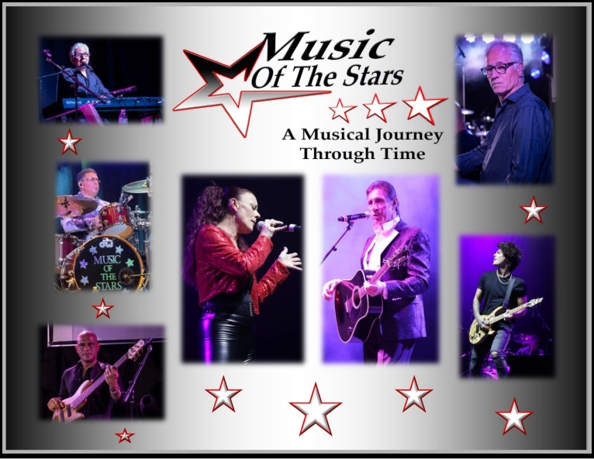

Contact Information:
John Dretto
Maestro Management
(585) 732-5100
maestromanagement@rochester.rr.com
www.musicofthestars.net
FOR IMMEDIATE RELEASE: December 20, 2022
“Upstate NY Touring Band Announces New Lineup”
Rochester, New York – "Music Of The Stars", a seven-piece tribute band based in Rochester, recently added three musicians with years of performing and touring experience to their lineup. The band has been performing throughout the United States since 2016, at casinos, hotels, corporate events, concerts and private functions.
Frank Shrout, lead vocalist and founder, announced; "We're very excited to have Rhonda Federation, an outstanding vocalist with an amazing voice, join us. She has toured nationally and internationally. She entertained American troops in Japan, performed at three Super bowls, opened for Gladys Knight and the Pips, The Doobie Brothers and Natalie Cole. Her repertoire includes songs that few vocalists can perform. Mark Balestra has been playing professionally since 1988. He is a Graduate of the prestigious Berklee College of Music. He has performed with numerous bands as well as several live stage shows and theater. Mark has recorded numerous local, regional and nationals jingles, including Wegman’s and Buick. Bass man Willie Lopez is a Western New York institution. With years of performing and touring experience, his hard driving style, along with drummer Fabian Provenza, anchors the band’s sound."
Rounding out the lineup are veterans Karl LaPorta on piano and vocals and Peter Riccardi on keyboards and synths. Music Of The Stars performs songs by international artists like Bee Gees, Elton John, Beatles, Neil Diamond, Tom Jones, Elvis, Tina Turner, Whitney and Celine to name a few.
Frank Shrout notes; “It's all about the music. We honor the artists and their songs."
###

